**A DISTANCE SENSOR (HCSR-04) OPERATED – AUTOMATED WATER TANK MANAGEMENT SYSTEM**

**WITH VOLTAGE DIVIDER**

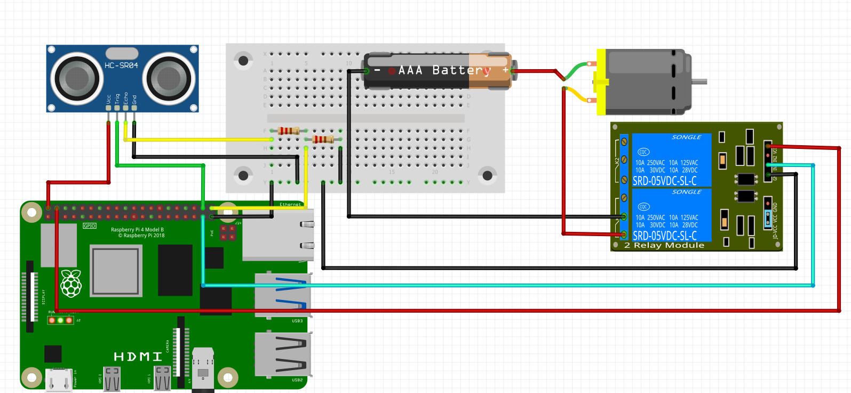

**IN1**

**5V**

**NO1**

**PIN 21**

**POWER SOURCE**

1K / 2K Voltage Divider.

GPIO PIN IS 5 VOLTS

HCSR04 WORKS ON 3V

**PUMP SIMULATION**

**COM1**

**HANDOUT 3**

**2K**

**1K**

**GND**

**PIN 20**

**PIN 26**

**GND**

**5V**

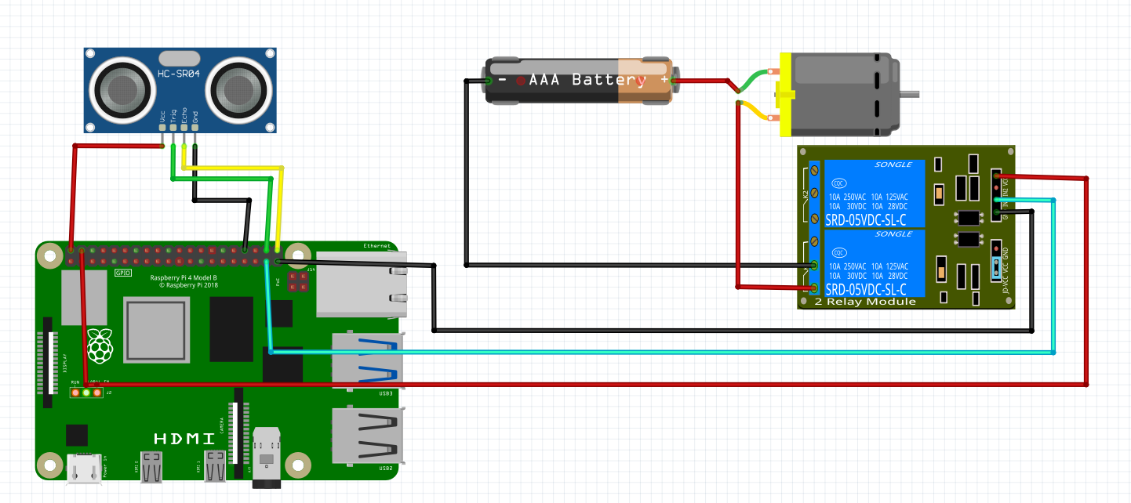

**5V**

**GND**

**NO VOLTAGE DIVIDER**

**POWER SOURCE**

**HANDOUT 3A**

**PUMP SIMULATION**

**IN1**

**NO1**

**COM1**

**PIN 26**

**PIN 21**

**PIN 20**